# CL118

**Programming Fundamentals**

# Lab 01

Pre-Programming phase



FAST – National University of Computer & Emerging Sciences Karachi, Pakistan

Lab Instructor: Romasha Khurshid

Romasha.khurshid@nu.edu.pk

**LAB 01**

**Learning Objectives**

This lab will cover the following topics:

* Problem Solving Concepts for the Computer
* Pre-Programming Phase
* Introduction to flow chart

## Problem Solving Process General Problem-Solving Method

1. Define and understand problem
2. Sketch the problem
3. Gather information
4. Generate and evaluate potential solutions
   1. Use applicable theories and assumptions
5. Refine and implement solution
6. Verify and test solution

## What Problem Can Be Solved by Computer

* When the solution can be produced by a set of step-by-step procedures or actions.
* This step-by-step action is called an algorithm.
* The algorithm will process some inputs and produced output.
* Solving problem by computer undergo two phases:

#### Phase 1:

* + - Organizing the problem or pre-programming phase.

#### Phase 2:

* + - Programming phase.

## PRE-PROGRAMMING PHASE

This phase requires five steps:

1. Analyzing the problem.
2. Developing the Hierarchy Input Process Output (HIPO) chart or Interactivity Chart (IC).
3. Developing the Input-Process-Output (IPO) Chart.
4. Drawing the Program flowcharts.
5. Writing the algorithms

### Analyzing the Problem

* + - Understand and analyze the problem to determine whether it can be solved by a computer.
    - Analyze the requirements of the problem.
    - Identify the following:
      * Data requirement.
      * Processing requirement or procedures that will be needed to solve the problem.
      * The output.
    - All These requirements can be presented in a Problem Analysis Chart (PAC)

|  |  |  |
| --- | --- | --- |
| **Data** | **Processing** | **Output** |
| Given in the problem or provided by the user. | List of processing required or procedures. | Output requirement. |

#### Example # 01:

Write a Problem Analysis Chart (PAC) to find an area of a circle where

## area = pi * radius * radius

|  |  |  |
| --- | --- | --- |
| **Data** | **Processing** | **Output** |
| Radius | area = 3.14 x radius x radius | area |

### Developing the Hierarchy Input Process Output (HIPO) or Interactivity Chart

* The problem is normally big and complex.
* Thus, requires big program.
* Thus, the processing can be divided into subtasks called modules.
* Each module accomplishes one function.
* These modules are connected to each other to show the interaction of processing between the modules.
* Main/control module controls the flow all other modules.
* The IC is developed using top-down-method: top to down left to right order (also refer to order of processing).
* Modules are numbered, marked for duplication, repetition or decision.

The interaction will form a hierarchy, called Hierarchy Input Process Output Chart (HIPO) or Interactivity Chart (IC). Programming which use this approach (problem is divided into subtasks) is called ***Structured Programming***.

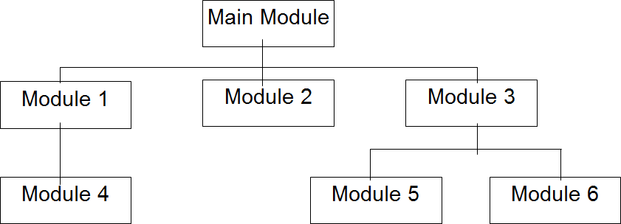

**Example #02:**

Write a Hierarchy Input Process Output (HIPO) that asks a user to enter the distance

of a trip in miles, the miles per gallon estimate for the user’s car, and the average

cost of a gallon of gas. Calculate and display the number of gallons of gas needed

and the estimated cost of the trip.

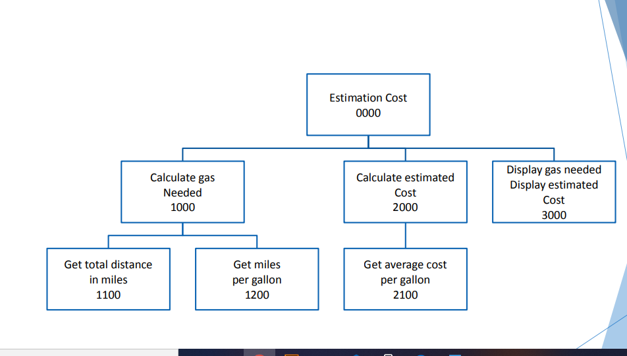

* 1. **Developing the Input Process Output (IPO) Chart**
     + Extends and organizes the information in the Problem Analysis Chart.
     + It shows in more detail what data items are inputs, what is the processing or modules on that data, and what will be the result or output.
     + It combines information from PAC and HIPO Chart.

#### Example # 03:

#### 

## LAB TASK

**Question # 01:** Write a Problem Analysis Chart (PAC) to calculate the gross pay of an employee given the hours worked and the rate of pay.